
Bird-O
Style guide

Young bird flyin up now, 'member back then worms clowned on me
Now from the Heaven gates only way a worm lookin' down on me
Keep at least two hundred thou' on mе, keep at least like thirty rounds on me
With my birds 'til thе nest fall off, gotta get back to our tree

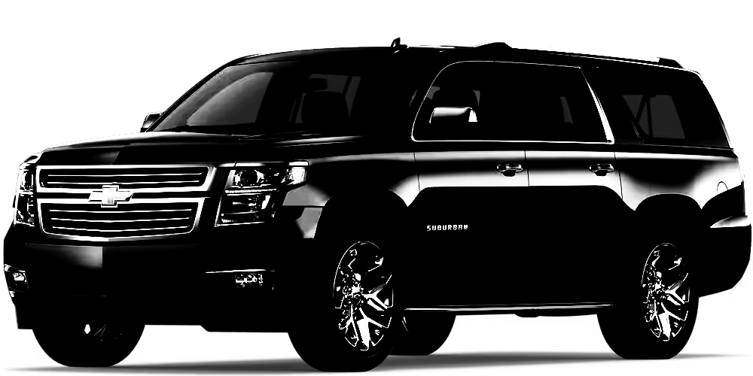
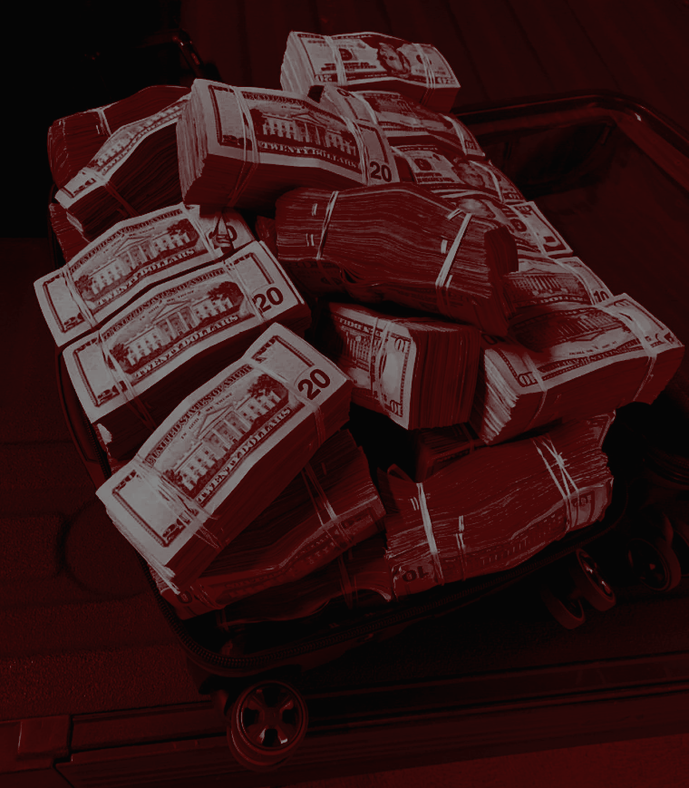
Bright Colors Top Down Chill out birdz gotta stay relaxed keep it bright stylistically.

Primary color: Bright & Gangsta
Bench Color: Brown
Worm Color: Pink
Bird Color: Black & yellow


